UNITED STATES
SECURITIES AND EXCHANGE COMMISSION
Washington, D.C. 20549
______________________

SCHEDULE 14A

Proxy Statement Pursuant to Section 14(a)
of the Securities Exchange Act of 1934
______________________

Filed by the Registrant ⌧ Filed by a Party other than the Registrant □

Check the appropriate box:

□ Preliminary Proxy Statement
□ Confidential, for Use of the Commission Only (as permitted by Rule 14a-6(e)(2))
□ Definitive Proxy Statement
⌧ Definitive Additional Materials
□ Soliciting Material Under §240.14a-12

CME GROUP INC.
(Name of Registrant as Specified In Its Charter)

Not Applicable
(Name of Person(s) Filing Proxy Statement, if other than the Registrant)

Payment of Filing Fee (Check the appropriate box):

⌧ No fee required.
□ Fee paid previously with preliminary materials.
□ Fee computed on table in exhibit required by Item 25(b) per Exchange Act Rules 14a-6(i)(1) and 0-11
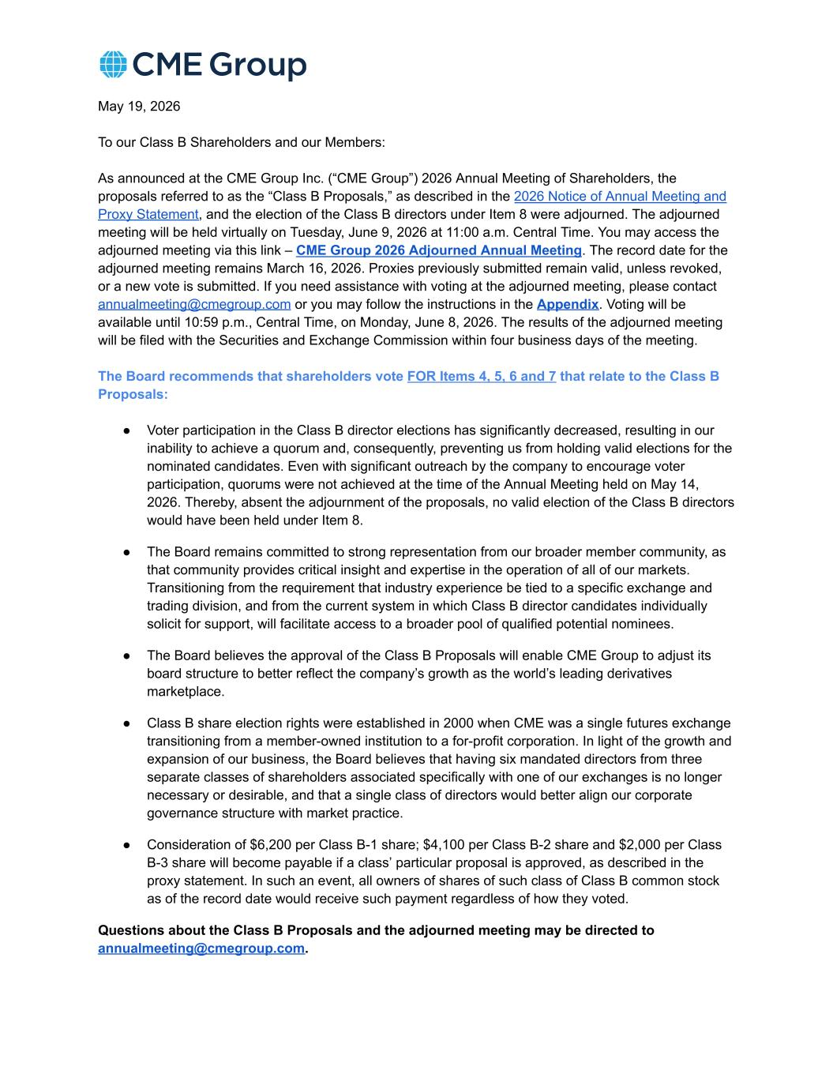

​May 19, 2026​ ​To our Class B Shareholders and our Members:​ ​As announced at the CME Group Inc. (“CME Group”) 2026 Annual Meeting of Shareholders, the​ ​proposals referred to as the “Class B Proposals,” as described in the​​2026 Notice of Annual Meeting and​ ​Proxy Statement​​, and the election of the Class B directors under Item 8 were adjourned. The adjourned​ ​meeting will be held virtually on Tuesday, June 9, 2026 at 11:00 a.m. Central Time. You may access the​ ​adjourned meeting via this link –​​CME Group 2026 Adjourned Annual Meeting​​. The record date for the​ ​adjourned meeting remains March 16, 2026. Proxies previously submitted remain valid, unless revoked,​ ​or a new vote is submitted. If you need assistance with voting at the adjourned meeting, please contact​ ​annualmeeting@cmegroup.com​​or you may follow the instructions in the​​Appendix​​. Voting will be​ ​available until 10:59 p.m., Central Time, on Monday, June 8, 2026. The results of the adjourned meeting​ ​will be filed with the Securities and Exchange Commission within four business days of the meeting.​ ​The Board recommends that shareholders vote​​FOR Items 4, 5, 6 and 7​​that relate to the Class B​ ​Proposals:​ ​●​ ​Voter participation in the Class B director elections has significantly decreased, resulting in our​ ​inability to achieve a quorum and, consequently, preventing us from holding valid elections for the​ ​nominated candidates. Even with significant outreach by the company to encourage voter​ ​participation, quorums were not achieved at the time of the Annual Meeting held on May 14,​ ​2026. Thereby, absent the adjournment of the proposals, no valid election of the Class B directors​ ​would have been held under Item 8.​ ​●​ ​The Board remains committed to strong representation from our broader member community, as​ ​that community provides critical insight and expertise in the operation of all of our markets.​ ​Transitioning from the requirement that industry experience be tied to a specific exchange and​ ​trading division, and from the current system in which Class B director candidates individually​ ​solicit for support, will facilitate access to a broader pool of qualified potential nominees.​ ​●​ ​The Board believes the approval of the Class B Proposals will enable CME Group to adjust its​ ​board structure to better reflect the company’s growth as the world’s leading derivatives​ ​marketplace.​ ​●​ ​Class B share election rights were established in 2000 when CME was a single futures exchange​ ​transitioning from a member-owned institution to a for-profit corporation. In light of the growth and​ ​expansion of our business, the Board believes that having six mandated directors from three​ ​separate classes of shareholders associated specifically with one of our exchanges is no longer​ ​necessary or desirable, and that a single class of directors would better align our corporate​ ​governance structure with market practice.​ ​●​ ​Consideration of $6,200 per Class B-1 share; $4,100 per Class B-2 share and $2,000 per Class​ ​B-3 share will become payable if a class’ particular proposal is approved, as described in the​ ​proxy statement. In such an event, all owners of shares of such class of Class B common stock​ ​as of the record date would receive such payment regardless of how they voted.​ ​Questions about the Class B Proposals and the adjourned meeting may be directed to​ ​annualmeeting@cmegroup.com​​.​

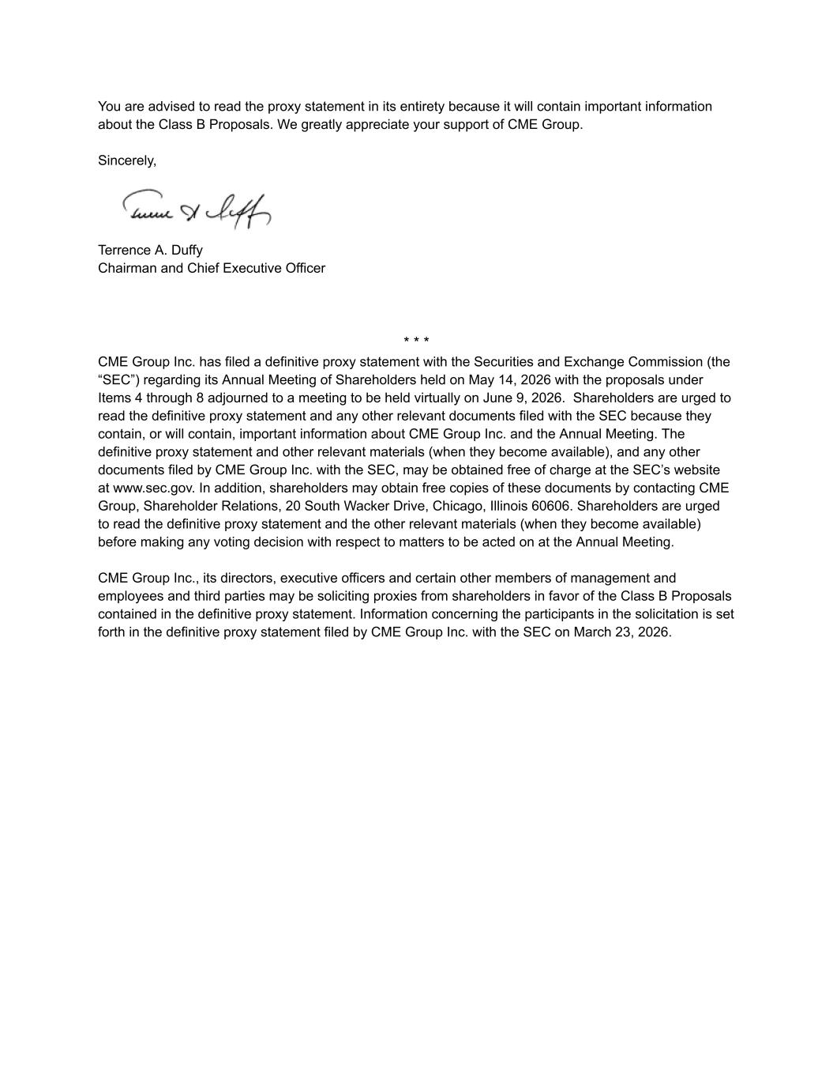
​You are advised to read the proxy statement in its entirety because it will contain important information​ ​about the Class B Proposals. We greatly appreciate your support of CME Group.​ ​Sincerely,​ ​Terrence A. Duffy​ ​Chairman and Chief Executive Officer​ ​* * *​ ​CME Group Inc. has filed a definitive proxy statement with the Securities and Exchange Commission (the​ ​“SEC”) regarding its Annual Meeting of Shareholders held on May 14, 2026 with the proposals under​ ​Items 4 through 8 adjourned to a meeting to be held virtually on June 9, 2026. Shareholders are urged to​ ​read the definitive proxy statement and any other relevant documents filed with the SEC because they​ ​contain, or will contain, important information about CME Group Inc. and the Annual Meeting. The​ ​definitive proxy statement and other relevant materials (when they become available), and any other​ ​documents filed by CME Group Inc. with the SEC, may be obtained free of charge at the SEC’s website​ ​at www.sec.gov. In addition, shareholders may obtain free copies of these documents by contacting CME​ ​Group, Shareholder Relations, 20 South Wacker Drive, Chicago, Illinois 60606. Shareholders are urged​ ​to read the definitive proxy statement and the other relevant materials (when they become available)​ ​before making any voting decision with respect to matters to be acted on at the Annual Meeting.​ ​CME Group Inc., its directors, executive officers and certain other members of management and​ ​employees and third parties may be soliciting proxies from shareholders in favor of the Class B Proposals​ ​contained in the definitive proxy statement. Information concerning the participants in the solicitation is set​ ​forth in the definitive proxy statement filed by CME Group Inc. with the SEC on March 23, 2026.​


​Appendix​ ​If you cannot locate the written materials, you have the following options for voting or obtaining​ ​your control number:​ ​1.​ ​Vote by Phone:​​Sodali, our proxy solicitor, can take​​your votes over the phone.​ ​○​ ​Toll-free (US):​​888-777-2094​ ​○​ ​Non-US:​​775-284-8673​ ​2.​ ​Vote Online (with Control Number):​​Contact Broadridge,​​the Inspector of Election, to​ ​get your 16-digit control number(s).​ ​○​ ​Toll-free (US): 866-232-3037​ ​○​ ​Non-U.S. toll free: 720-358-3640​ ​Once you have your control number(s), you can then vote your shares online at​ ​https://proxyvote.com​ ​You will need to provide the names and addresses tied to your account(s) at the transfer​ ​agent, Computershare, when calling. You can contact​​annualmeeting@cmegroup.com​​if​ ​you are unsure of the information on your account(s).​

